**Project Planning Phase**

**Project Planning Template (Product Backlog, Sprint Planning, Stories, Story points)**

|  |  |
| --- | --- |
| Date | 18 October 2022 |
| Team ID | PNT2022TMID28495 |
| Project Name | Deep Learning Fundus Image Analysis for Early Detection Of Diabetic Retinopathy |
| Maximum Marks | 8 Marks |

**Product Backlog, Sprint Schedule, and Estimation (4 Marks)**

Use the below template to create product backlog and sprint schedule

| **Sprint** | **Functional Requirement (Epic)** | **User Story Number** | **User Story / Task** | **Story Points** | **Priority** | **Team Members** |
| --- | --- | --- | --- | --- | --- | --- |
| Sprint-1 | Registration | USN-1 | As a user, I can register for the application by entering my email, password, and confirming my password. | 2 | High | 2 |
| Sprint-1 |  | USN-2 | As a user, I will receive confirmation email once I have registered for the application | 1 | High | 2 |
| Sprint-2 |  | USN-3 | As a user, I can register for the application through Facebook | 2 | Low | 2 |
| Sprint-1 |  | USN-4 | As a user, I can register for the application through Gmail | 2 | Medium | 2 |
| Sprint-1 | Login | USN-5 | As a user, I can log into the application by entering email & password | 1 | High | 2 |
| Sprint-4 | Dashboard | USN-6 | User can view their dashboard | 2 | Medium | 3 |
| Sprint-2 | Validation | USN-7 | Validates User Login Credentials | 2 | Low | 2 |
| Sprint-3 | Patients’s name and ID | USN-8 | Doctor uses this report for monitoring patient’s activity | 1 | Medium | 3 |
| Sprint-2 | Upload Images | USN-9 | Predicting part | 2 | High | 4 |
| Sprint-4 | Logout | USN-10 | Logout as a current user | 2 | High | 3 |

**Project Tracker, Velocity & Burndown Chart: (4 Marks)**

| **Sprint** | **Total Story Points** | **Duration** | **Sprint Start Date** | **Sprint End Date (Planned)** | **Story Points Completed (as on Planned End Date)** | **Sprint Release Date (Actual)** |
| --- | --- | --- | --- | --- | --- | --- |
| Sprint-1 | 20 | 6 Days | 24 Oct 2022 | 29 Oct 2022 | 20 | 29 Oct 2022 |
| Sprint-2 | 20 | 6 Days | 31 Oct 2022 | 05 Nov 2022 | 16 | 05 Nov 2022 |
| Sprint-3 | 20 | 6 Days | 07 Nov 2022 | 12 Nov 2022 | 18 | 12 Nov 2022 |
| Sprint-4 | 20 | 6 Days | 14 Nov 2022 | 19 Nov 2022 | 15 | 19 Nov 2022 |

**Velocity:**



Velocity for Sprint-1= 20/8 =2.5

Velocity for Sprint-1= 20/10 =2

Velocity for Sprint-1= 20/8 =2.5

Velocity for Sprint-1= 20/10 =2.

**Burndown Chart:** A burn down chart is a graphical representation of work left to do versus time. It is often used in agile[software development](https://www.visual-paradigm.com/scrum/what-is-agile-software-development/) methodologies such as [Scrum](https://www.visual-paradigm.com/scrum/scrum-in-3-minutes/). However, burn down charts can be applied to any project containing measurable progress over time.

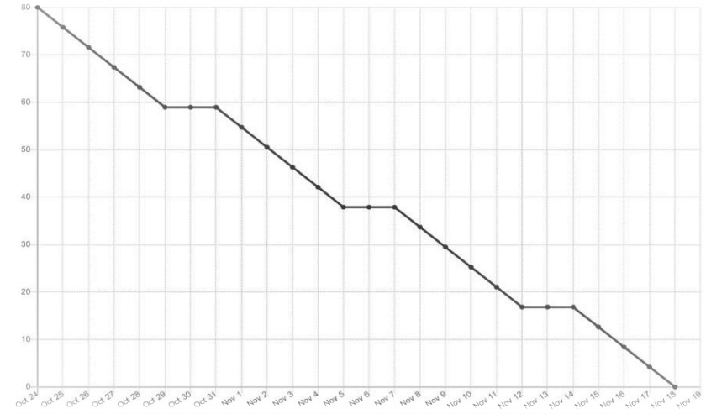

**Reference:**

**<https://www.atlassian.com/agile/project-management>**

**<https://www.atlassian.com/agile/tutorials/how-to-do-scrum-with-jira-software>**

**<https://www.atlassian.com/agile/tutorials/epics>**

**<https://www.atlassian.com/agile/tutorials/sprints>**

**<https://www.atlassian.com/agile/project-management/estimation>**

**<https://www.atlassian.com/agile/tutorials/burndown-charts>**